MEMS packaging simulation

An electro-thermal simulation of a MEMS device was performed, in order to determine the heat transfer within the packaged device and the heat dissipation in the air region around it.
The silicon MEMS device is a gas sensor, with a Pt resistor on top of a thin, suspended membrane. With a small power consumption (up to mW), the MEMS micro-heater can heat the sensing area very fast, up to hundreds of degrees C. Due to the high temperatures involved, packaging is a sensitive aspect of such devices.
The simulation results provided the necessary information for designing an optimum package, in terms of materials used, geometry and dimensions.

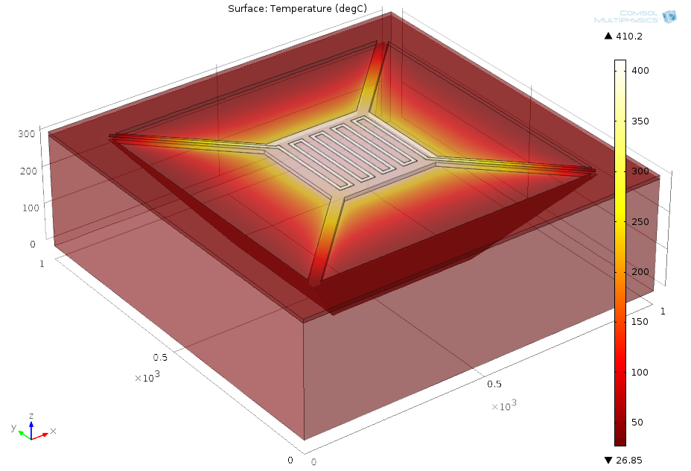
Temperature distribution within the MEMS heater
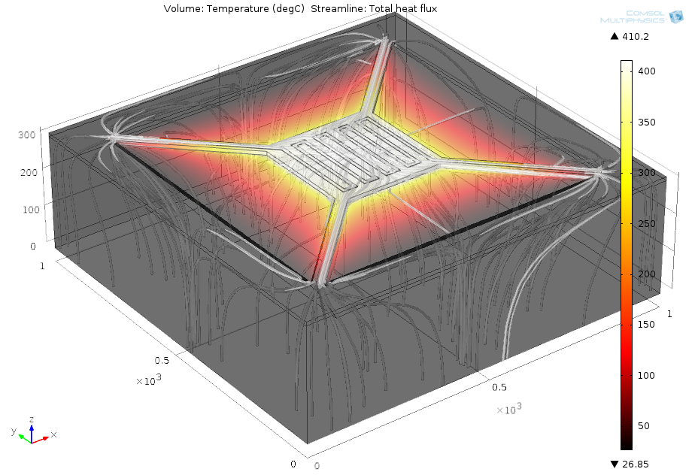
Temperature distribution within the MEMS heater and the heat flux
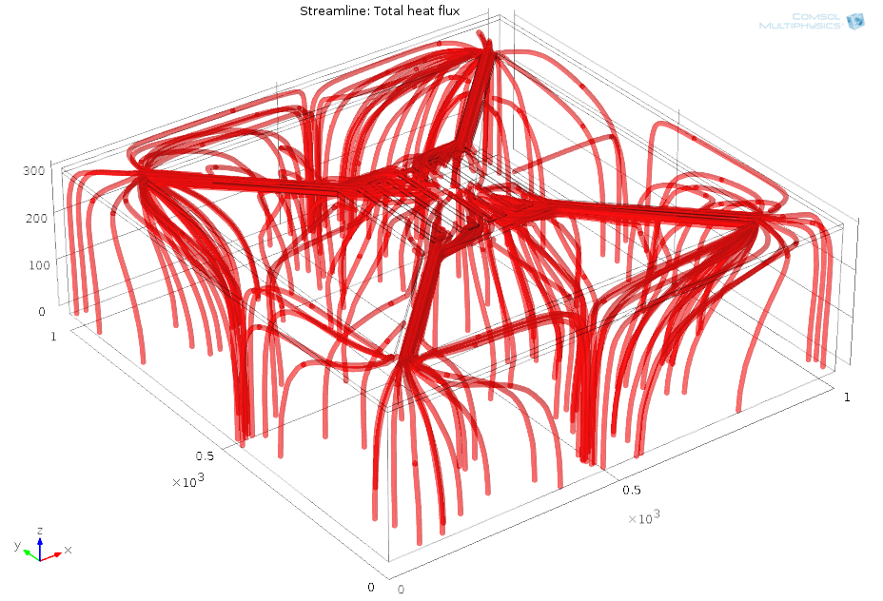
Heat flux within the MEMS heater
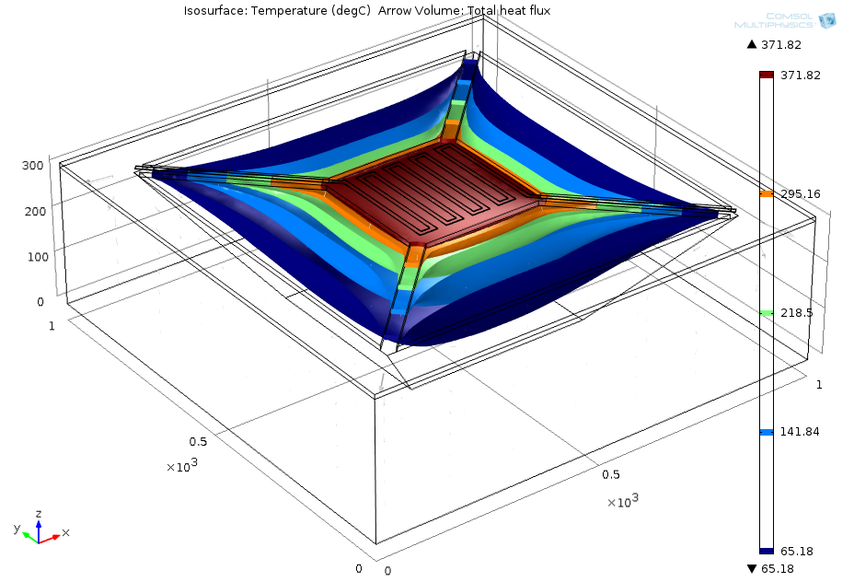
Temperature distribution within the air region under the membrane – isosurface

